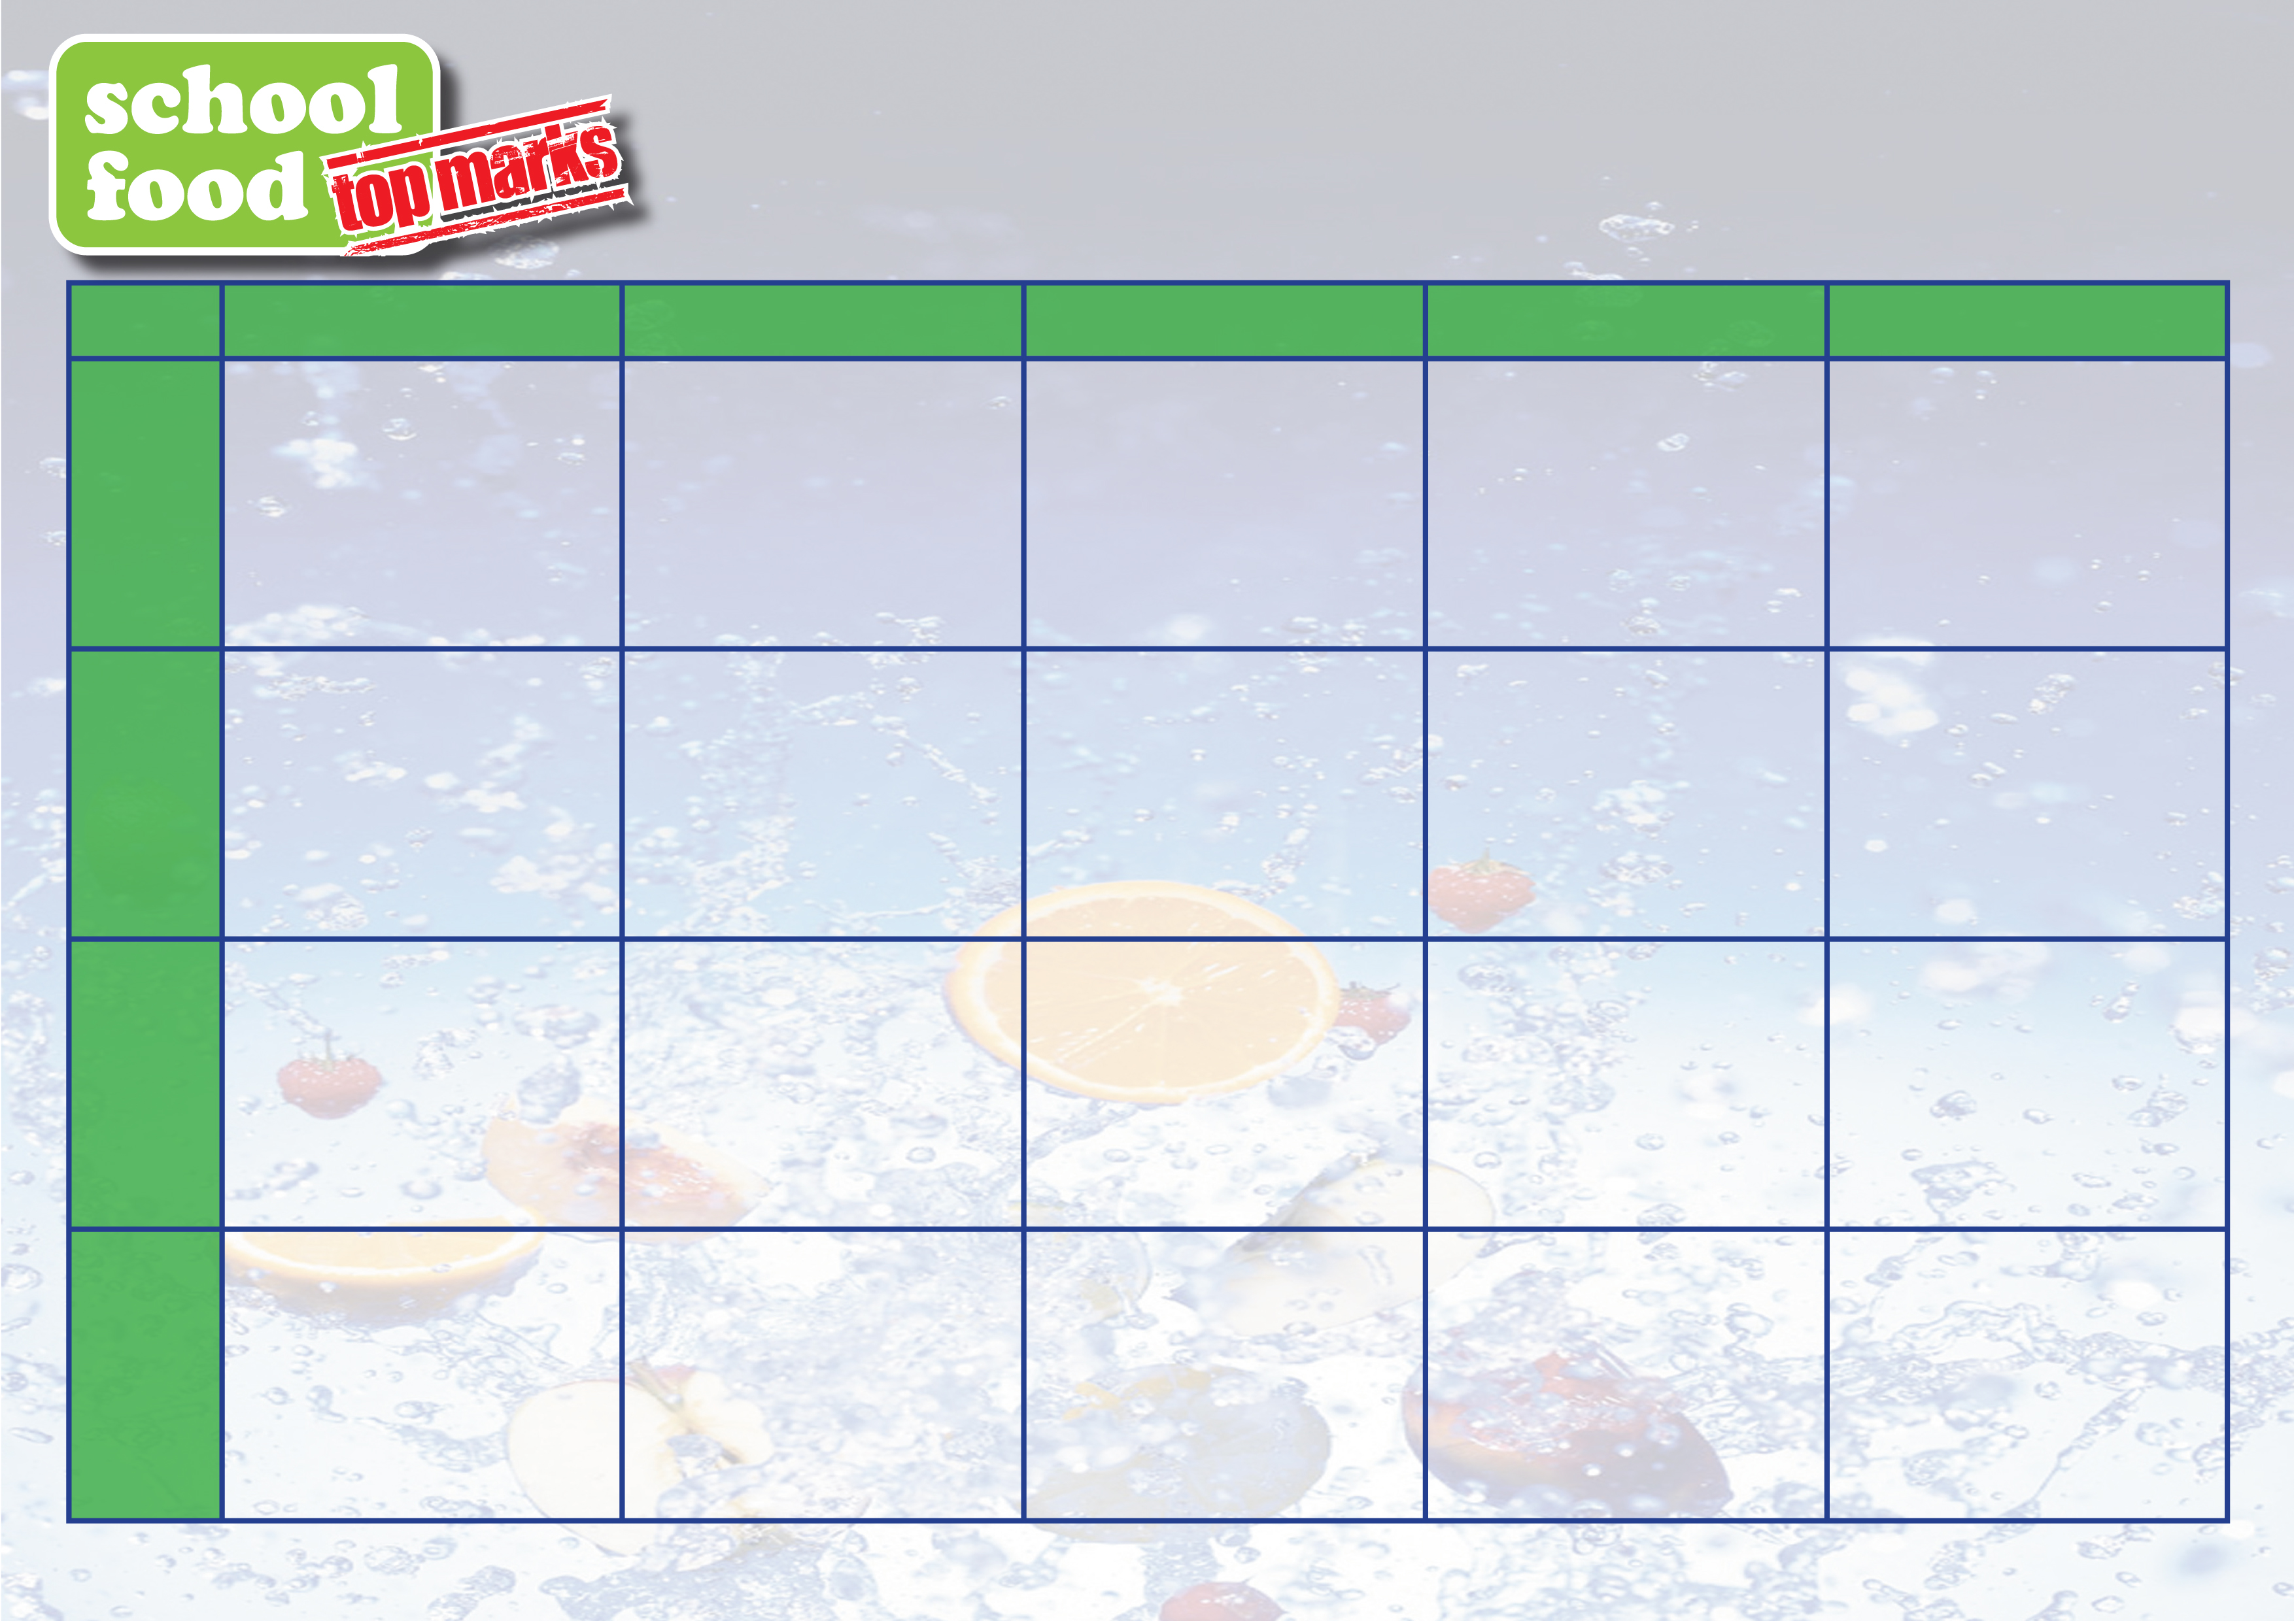
Spaghetti Bolognaise or Fish Fingers, Vegetables, Mashed Potato or Pasta
*
Sponge & Custard

Chicken Curry & Rice or Oven Baked Sausages, Creamed Potato, Sauté Potato & Vegetables
*
Rice Pudding

Roast Chicken, Roast, Creamed Potato, Carrots & Peas
*
Frozen Yoghurt
Oven Baked Fish or Chicken Wrap, Creamed Potato and Sauté Potato
*
Muffin & Fruit
Hamburger & Chips
*
Ice Cream
Savoury Mince or Fish Fingers, Peas, Creamed Potato or Pasta
*
Sponge & Custard

Roast Chicken, Roast, Creamed Potato, Carrots & Peas
*
Frozen Yoghurt & Fruit

School Closed
For St Patrick’s Day

Chicken Baguette or Sausages, Creamed Potato, Sauté Potato & Vegetables
*
Flakemeal Biscuit
St Patrick’s Day
Wear Green to School

Chicken Nuggets & Chips

*
Ice Cream & Fruit
Parents of children starting on the 8th March, please continue to pay with the parent pay app.

Monday
Tuesday
Wednesday
Thursday
Friday

Week 1
08-3-21

Week 2
15-3-21

North Eastern Education & Library Board
St Eoghan’s Primary School Meals Kitchen

