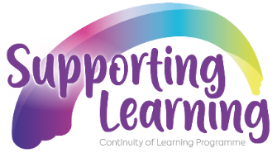

To: All primary and post-primary principals, teaching staff and governors

The Department of Education’s Curriculum, Qualifications and Standards Directorate (CQSD) has initiated a number of projects to ensure that appropriate action is taken to secure, as far as possible, the learning of pupils at home and in school, during the current pandemic and beyond.
The Continuity of Learning Project is focused on the production and dissemination of support and guidance for teachers, parents and learners, in relation to:
- Pastoral care, guidance and support;
- Innovative approaches to remote learning and teaching;
- High quality feedback and assessment;
- Providing for progression and transition; and
- Providing for the most vulnerable, disadvantaged and hard to reach.

As part of their work, the primary work-stream has consulted with a range of principals and practitioners to develop the guidance referenced below to support schools as they plan for the transition of children from primary to post-primary in the context of COVID-19. The purpose of these resources is to provide non-statutory guidance relating to the actions that schools may wish to consider to encourage continuity of learning for every child.

Transition from Year 7 to Year 8 in the COVID-19 context
https://sway.office.com/Fw5nXIKYHlhiFFP6?ref=Link

