School Safe Guarding Team

School Principal and Acting Deputy Designated Teacher: | Mr Paschal Diamond
The Designated Teacher: | Mrs Mairead Cunningham | 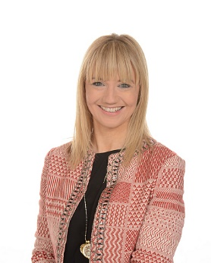
Chairperson of BOG | Mr Brian McGuigan
Governor with Special Responsibility  for Child Protection: | Mrs Aimee Quinn

